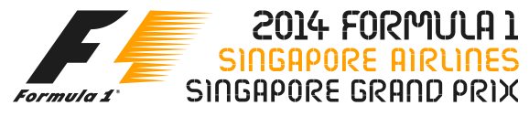

**ANNEX 1 – 2014 FORMULA 1 SINGAPORE AIRLINES SINGAPORE GRAND PRIX ENTERTAINMENT SCHEDULE\***

|  |  |  |  |
| --- | --- | --- | --- |
| DATE | ARTISTE | LOCATION | TIME |
| 19 September  Friday | **Mayday**  @Mayday_EN  #Mayday五月天‬‬‬‬‬‬‬‬‬ | **Padang Stage**  **(Zone 4)** | **Post**  **Formula One™ Practice** |
| 20 September  Saturday | **Pet Shop Boys**  www.petshopboys.co.uk  @petshopboys | **Village Stage**  **(Zone 1)** | **Pre**  **Formula One™ Qualifying** |
| 20 September  Saturday | **Ziggy Marley**  http://ziggymarley.com  @ziggymarley | **Village Stage**  **(Zone 1)** | **Post**  **Formula One™ Qualifying** |
| 20 September  Saturday | **Robbie Williams**  http://robbiewilliams.com @robbiewilliams | **Padang Stage**  **(Zone 4)** | **Post**  **Formula One™ Qualifying** |
| 21 September  Sunday | **Ziggy Marley**  http://ziggymarley.com  @ziggymarley | **Esplanade Outdoor Theatre (Zone 4)** | **Pre**  **Formula One™ Race** |
| 21 September  Sunday | **John Legend**  www.johnlegend.com  @johnlegend | **Village Stage**  **(Zone 1)** | **Pre**  **Formula One™**  **Race** |
| 21 September  Sunday | **Jennifer Lopez**  www.jenniferlopez.com  @JLo | **Padang Stage**  **(Zone 4)** | **Post**  **Formula One™**  **Race** |

* Artiste line-up, performance dates and stage venues are subject to change. The latest entertainment schedule will be updated periodically on www.singaporegp.sg.